### **BUS4 110B Systems Analysis and Design Sec. 2**

**Group 4**

**Housetimators Final Report**

**Report By:**

Deliverable 1- Project Lead Analyst: Neda Amin

Deliverable 4 - Back-End Engineer: Ricky Bhatia

Deliverable 6 - Implementation Analyst: Leila Nakasone

Deliverable 2 - Business Lead Analyst: Ryan Tran

Deliverable 5- Front-End Engineer: Charith Pete

### 

### 

### 

### 

### 

**Table of Contents**

**1.0 Introduction & Planning** **4**

1.1 Problem Statement 4

1.2 Background 5

1.3 Business Goals/ Project Objectives 6

1.4 Solution Description 6

1.5 Solution Rationales 7

**2.0 Analysis** **9**

2.1 Current System Overview (Current Process Analysis) 9

2.2 Requirement Analysis 10

2.3.1 Market Feasibility 11

2.3.2 Economic Feasibility: 12

2.3.3 Technical Feasibility: 13

2.4. Risk Analysis 13

2.4.1. Development Risk 13

2.4.2. Deployment Risk 14

2.4.3. Operational & Maintenance Risk 14

**3.0 Logical Design** **15**

3.1 Data Flow Diagrams 15

3.1.1 Context Diagram: 15

3.1.2 DFD 0: 16

3.1.3 Level-1 DFDs: 17

3.1.4 Combined Data Dictionary: 21

3.2 Use Cases and Process Models 24

3.3.1 Entity Relation Diagram 34

3.3.2 Data Model Specifications: 35

**4.0 System Architecture** **36**

4.1 Data Model 36

4.1.1 Entity Relationship Diagram (ERD) 36

4.1.2 Data Model Specifications 36

4.2. Cloud Architecture 37

4.2.1 Network & Web Tier 38

4.2.2 Application Server Tier 38

4.2.3 Database Tier 39

4.2.4 Authentication Tier and Security Configurations 39

**5.0 User Interface and User Experience** **40**

5.1 User Interface 40

5.1.1 Dialogue Diagram 41

5.2 User Experience (UI Prototypes) 41

**6.0 Implementation and Budget** **45**

6.1 Development and Test Plan 45

6.2 Public Launch, Installation or Deployment Plan 47

6.3 Maintenance Plan 48

6.4 Budget and Budget Narrative 48

**Appendix A** **52**

### 

### 

### 

### 

### 

### 

### 

### 

### 

### 1.0 Introduction & Planning

With the continual rise of housing prices across the nation, but more specifically in San Jose, California, many people are becoming wary about purchasing real estate. This is a big deal as many people save up their money over time in order to either invest in or purchase real estate. Everyone wants to be sure that they don’t overspend and put themselves in a financial hole further down the line, but the issue is that there’s no way to quantifiably figure out what something is worth. With this in mind, our project, Housetimators, aims to help all that are looking to purchase real estate by providing value estimates and other relevant information. We plan to analyze various data gathered from multiple listing services (MLSs) in order to accurately estimate the values of real estate. We should be able to see trends of when prices were high or low and pinpoint them to exact dates. Our service will help thousands of San Jose locals, and we expect that it will be very useful whether they are looking to rent, buy, or sell. In addition to providing property price estimates, we want to provide users with other information such as tax implications, potential investment value, the best time to sell property, best financing situations, and so on.

##### **1.1 Problem Statement**

Housestimators can help find accurate sale pricing for housing in the San Jose area. Each real estate pricing website shows similar prices, however all of their estimate ranges seem to be inaccurate. For example, on Redfin’s website, a home in the Willow Glen area is priced at $1.06 million, but the website estimates it’ll be sold ~$1.07 million. On Zillow, the same house is priced at $1.06 million as well, but estimates from $1.02m - $1.12m. These are extremely different price ranges for the same home and can confuse homebuyers. What our system can offer is a website that gives an honest, estimated price closer to reality, taking into consideration the average price of square footage and the current prices of homes in the area. Finding the right house has become a struggle for many people over the years, so our website can help families who are looking to move to San Jose or to find a new home. Some factors that need to be considered while developing this website is the constant market fluctuation. We also need to consider that there will be heavy traffic on our website, so we need to act efficiently to troubleshoot system errors. We would need to have qualified staff that can diagnose and resolve technical difficulties. This staff will also make updates and system maintenance for better user functionality.

##### **1.2 Background**

Our target audience for Housetimators is the San Jose community. It’s for people interested in selling their houses or are curious about their house value. It is also for potential buyers to learn about San Jose’s housing market. Anyone outside of San Jose will be able to view the housing prices in the area. Additional target audiences are investors and real estate agents. When you look at different real-estate sites, like Zillow, Trulia, or Redfin, not only are the price estimates different on each site, but they never provide a precise estimate of how much a house will be sold for. Some functionalities we are offering include the ability to check the value of the house weekly. Our customers will make a secure account and can access their recently viewed estate, view suggested houses, and could favorite potential houses to buy. We also want our users to check how the value of their house would change if they would renovate. For example, if they wanted to add an extra room, they would be able the appreciation in house value.

##### **1.3 Business Goals/ Project Objectives**

Our main objective for this project is to be able to eliminate or at least minimize the pricing discrepancy so that our consumers are being fed the most accurate information. Our other objectives include refined functionalities such as interactable maps, detailed descriptions, weekly updates, and a 24/7 live chat support. We want our users to be able to interact with the house through a screen to bring access to those who cannot physically tour the house. Housetimators will include a live map, such as the one used on Google. This will allow users to not only examine the house they are interested in but also see the surrounding area. Weekly updated listing prices is one of our main objectives when tackling this project. We believe that this functionality serves a great deal of importance because of how volatile the housing market can be. Swings in prices are extremely important when negotiating; consumers will now be able to get a chance to receive first notice. Searching for the perfect home can be very difficult at times, especially for those who are first time buyers. With little experience, home buyers are often left confused and lost after searching. With the implementation of a live support chat, buyers will be more informed and well guided.

##### **1.4 Solution Description**

Housetimator is a website that will stand out from competing real estate services due to our technological and predictive analytics functions. The website will have an accurate real estate estimator which will be monitored for accuracy and minimal deviations. Technologies that compose this will be made up of resources provided by census reports and historic housing data in the respective region in order to give the estimator an accurate reading. Prospective homebuyers unfamiliar to the city of San Jose looking to purchase real estate will benefit from this because they will be given an honest price point of home values along with additional information, key in finalizing a decision, regarding the area. As mentioned, Housetimators will have features enabling the user to stay up to date with house values, regional data, and updates in San Jose’s regions. There will be a live 24/7 communication server which will allow the user to chat with a professional San Jose based real estate expert. With Housetimators, users will be able to access a list of the top ten real estate agencies in the area and read and/or leave reviews. This will require third party data in order to provide the most accurate and reliable realtors. Having an accurate real estate estimator will be the most financial aspect of our website by stakeholders and users. The functionality and development of the estimator will be developed by software engineers and data analysts with professional experience in applied mathematics and statistical analysis. This ensures that the estimator will be at optimal performance. The estimator, along with the other resources and tools that the website includes all adds up to the user deciding whether or not they want to move further with purchasing a house in a certain region of San Jose.

##### **1.5 Solution Rationales**

After implementing this new system, we will be able to attract new clients to our website, assist with real estate transactions and be a source of marketing. Anyone will be able to access our website and check accurate estimates of property prices in San Jose and decide if they want to do business with us. By having an accurate real estate estimator, this will retain a large number of customers. Over time, we will attain an increased percentage of the market share. As mentioned previously, there is a huge interest in San Jose’s property, which leads to high volumes of people looking at the housing market. Not only will this project help our business but it will also be helpful for those in the community. People will be able to see if the area they are looking to purchase a home in is right for them, specifically looking at local school ratings, crime rate, taxes and much more. Prospective sellers will be able to use our service and see the provided statistics and data pertaining to their house value by comparing similar homes nearby.

### 

### 2.0 Analysis

##### **2.1 Current System Overview (Current Process Analysis)**

1. The current website systems that are used for real estate listings use similar algorithms to show pricing in areas around the U.S. Most real estate websites begin with showing pictures of the specified home one’s interested in. It also provides general information, including descriptions of square footage, bedrooms, bathrooms, neighborhood, and previous pricings. The listings typically provide an estimated price, estimated pricing range and the actual listed price. On some websites at the end of each house listing they may offer several real estate agencies and open house dates or options.
2. Most current housing websites provide a sufficient amount of information regarding homes and surrounding areas, however, the main issue that we would like to tackle with our new system is accurate pricing. Current websites provide estimated costs and price ranges, but these prices are far off the sold price. Although these systems show pictures and descriptions of homes, they may not always present an accurate depiction of what the house looks like. Another helpful feature that some of these websites is lacking is the option to view the changes in a home’s price if owners were to renovate it.
3. The goal of our solution is to offer efficiency and accurate pricing compared to previous systems used for real estate. Our project will result in options to view prices and all estimated ranges that accurately shows what a house is sold for in the market. Overall, the added changes to our system can offer several options that will be helpful to buyers in the market.

##### **2.2 Requirement Analysis**

Accurately valuing a home is a difficult task given the numerous variables that go into determining the listing price. Due to this, listing prices are often skewed and inaccurate on all of the current sites. Our system requirements for our website is based on user preferences and analysis of current system documents. This includes a registration system, an accurate listing price, a security system, and a user friendly interface. The problem with current listing websites are that their prices often do not match the final sale price. The reasoning for this discrepancy could be linked to differences in opinions during the negotiation process or outside factors that could affect the house price. Current systems use statistical learning models and sophisticated algorithms to determine a listing price. Many popular listing sites attempt to resolve this issue through system updates, while others seem to accept it is an issue. Our system will aim to not only use these tools, but include frequent user inputted data to help us determine the value of their home. There are no other current systems that will have to be linked to ours because we are an independent system similar to Zillow. There is no new technology being used for this project; only the refinement of current technology and the introduction of user interaction with the listing. Questions of security will rise due to the system asking for user information inputs. We will eliminate any potential information breaches through an implementation of a security system. In terms of data processing, our clients are receiving a refined system that will enable them to view live changes of the pricing of homes as well as the general offered functions like house details, area specifics, and homeowner information. Our new data processing activities will produce more efficient and more effective ways to shop for homes. This is done through cross-checking and analyzing the data from houses sold in the past in the area of the listed house.

**Functional Requirement**

Client

* Client must be signed into a registration system
* Client must be able to verify registration
* Client must be able to contact the listing agent
* Client must be able to view details of surrounding area
* Client must be able to contact live support server 24/7
* Client must be able to view listing details

**Non functional Requirements**

* System must be available on the internet
* User information must not be released by database
* Institutional employees must be verified/authenticated
* Institutional employees may have information on users with user consent

**2.3 Feasibility Study**

##### *2.3.1 Market Feasibility*

Real estate data, especially prices, are listed on many websites with their prices fluctuating between them. The issue with this is that prospective buyers and homeowners aren’t receiving accurate information about the real estate they’re interested in due to such variance. For instance, Zillow shows a house in San Jose that lost value after being sold and now estimates it to be $944,698, meanwhile Trulia shows it at $975,000. Our website will assess the current market, also known as a comparative market analysis in the real estate industry, to try to calculate the most reasonable and accurate house pricing. As expected, these other websites are the current competitors, but their websites display variances in their data and do not have the same algorithms developed by our software engineers and staticians to pinpoint accurate prices. The traffic will come from interested homeowners, prospective buyers, census bureaus, and real estate agents, which will bring some reputation along with it. Our potential source of revenue will come from companies and real estate agencies partnering with us to provide listings and tools from the website’s additional features. Since we aren’t selling a product, there are no prospective buyers, unless a larger real estate company offers, but more so seeking an audience.

##### *2.3.2 Economic Feasibility:*

The software from this website is meant to make the real estate data analysis process more efficient and accurate. To maintain it and keep the website running, we would need a strong team of engineers, staticians, business management, and public relations. Having these crucial members on a team adds to our operating expenses. Roughly $1.5 to $2 million would need to be in the budget to keep these employees, which will eventually lead to more accurate price estimation. Additionally, this will benefit the users as they too will incur less expenses by avoiding third party inspectors. We also expect to have recurring fixed costs for operating our website. With the yearly renewal of our domain, monthly web hosting, and client security, we expect to be budgeting around $1000- $1500 to remain publicly operational.

##### *2.3.3 Technical Feasibility:*

The software that we are implementing has been around for 15 years. Since this technology exists within other real-estate websites, the features we want to add should not be difficult to implement. Some features we would be applying to our system would allow users to see the cost of their house if they decide to renovate it. Another software feature we are implementing is the live map. We have enough technical experience to be able to maintain this technology in the future, and we have a highly-trained IT team that will maintain our system. With our background knowledge and the experience we’ve allocated, we have enough technical experience to add this feature to our system. Our system is user-friendly, making it easy for users to utilize our system. Hardware systems we have to keep in check is our servers, specifically the chat server.

##### **2.4. Risk Analysis**

##### *2.4.1. Development Risk*

The software we will be using to estimate the prices of property might cause confusion or skepticism with clients as they may feel that they aren’t being provided with accurate estimates. Each property estimate will vary accordingly based on characteristics such as land size, bedrooms, and bathrooms. Users will be provided with this information on the side next to the property they are trying to find an estimate for. Real estate agents and staff involved with our service will have the opportunity to attend an informational seminar which will help familiarize them with our website and our estimate methodology. Since technology is advancing, further down the line we may be able to provide precise calculations and technology specialists will resolve any systematic issues.

##### *2.4.2. Deployment Risk*

Since we require real estate information for our service to work, we require a large database or storage server for all our property information. Specifically, we would need access to the MLS in order for us to be able to provide users with real estate estimates. This part can be quite challenging as it’s time consuming and can get expensive. In order to mitigate these deployment risks, we must ensure we have a database and server large enough to host our service. We would also need to implement a system where corrupt files or missing data is stricken from the data.

##### *2.4.3. Operational & Maintenance Risk*

As this is a new system, building it can be quite difficult to get everything going. It is imperative we figure out the appropriate calculation methods when providing users with estimates since this could become quite tedious. A viable option would be to assess and analyze them to figure out methodology to provide much more accurate estimates. Our service will be quite user friendly to the point where users fill out information such as address, land size, number of bedrooms/bathrooms. This would mean there would be little to no operational or maintenance risks. If users are having difficulty navigating our website then we’ll provide chat support and email where we can go through the estimate with them.

### 

### 3.0 Logical Design

##### **3.1 Data Flow Diagrams**

##### *3.1.1 Context Diagram:*

Below is our context diagram for Houstimators. This shows the main data flow of our system and to define our systems boundaries. Houstimator not only connects with the admin, but with the home buyer, the bank and realtors as well.

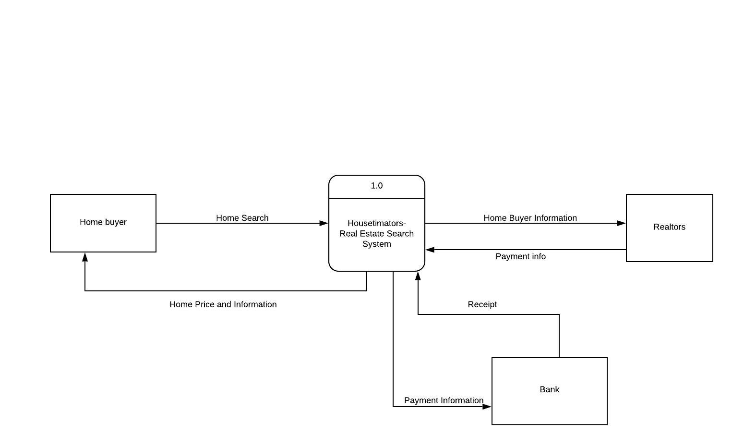

##### *3.1.2 DFD 0:*

Below is our level-0 diagram for Houstimators. This shows where all the data is stored, how the data flows and the major processes.

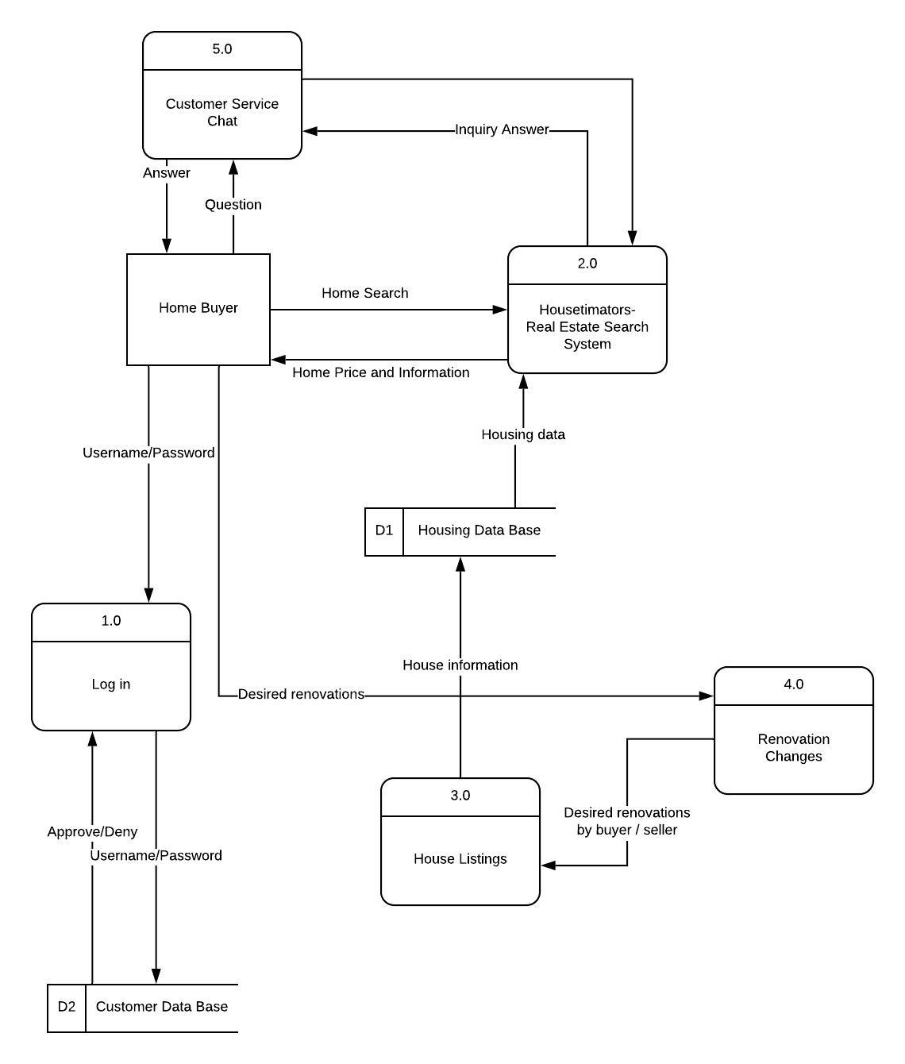

##### *3.1.3 Level-1 DFDs:*

Below is each level-1 diagram for Houstimator’s level-0 processes. They are a breakdown of the process in better detail.

*DFD 1 Log-in****:***  This is the first step inorder for our users to access Houstimators. The breakdown of the login process is that it starts with the user entering their log-in information to our website. Once they are verified, they have a confirmation and are now able to access our website. Now they can access their profile and view the house listed. When they are in the website, they can also create a new password, which then updates the information in the customer database using the username for it to be verified. . 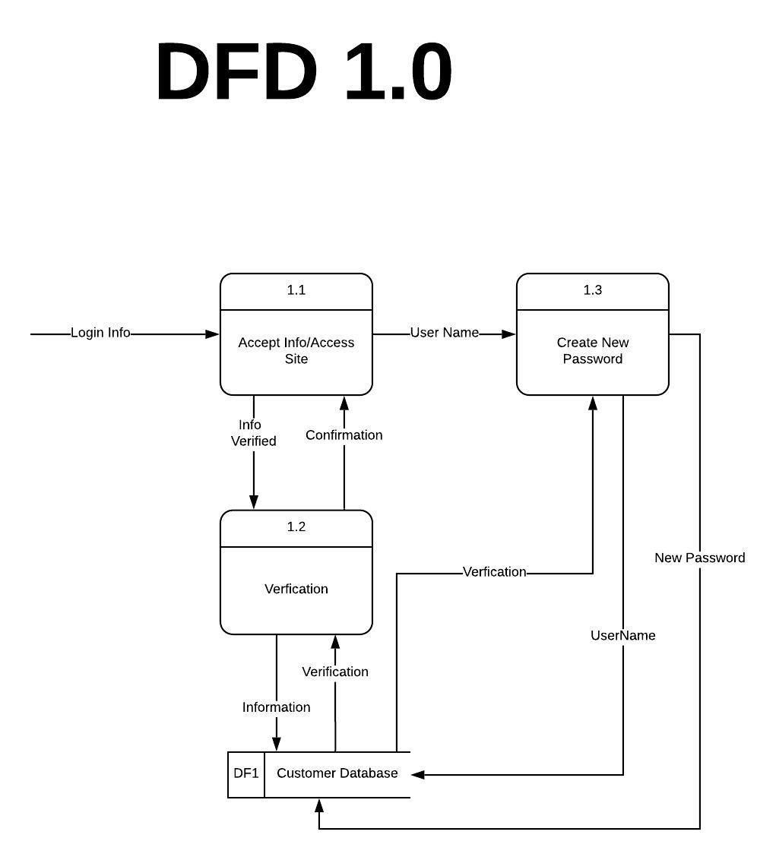

*DFD 2 Real-Estate Search System:* This process is initiated by either seller or buyer accessing the website where they will have the option of either inputting their own property details or searching for various properties with specific filters selected. From there, that information will be relayed through our search system and enter our database. If a seller has initiated this process then their property details will be saved onto our database before it is sent to our estimation system. All price estimates that potential sellers receive will be saved in our system to compare the data for future use. If a buyer has initiated the process then all the details they requested will be retrieved from our database and a list of properties will be available for the potential buyer to view. If any issues arise such as incorrect property information being sent back to users, the admin will have the ability to access the database and maintain all resources.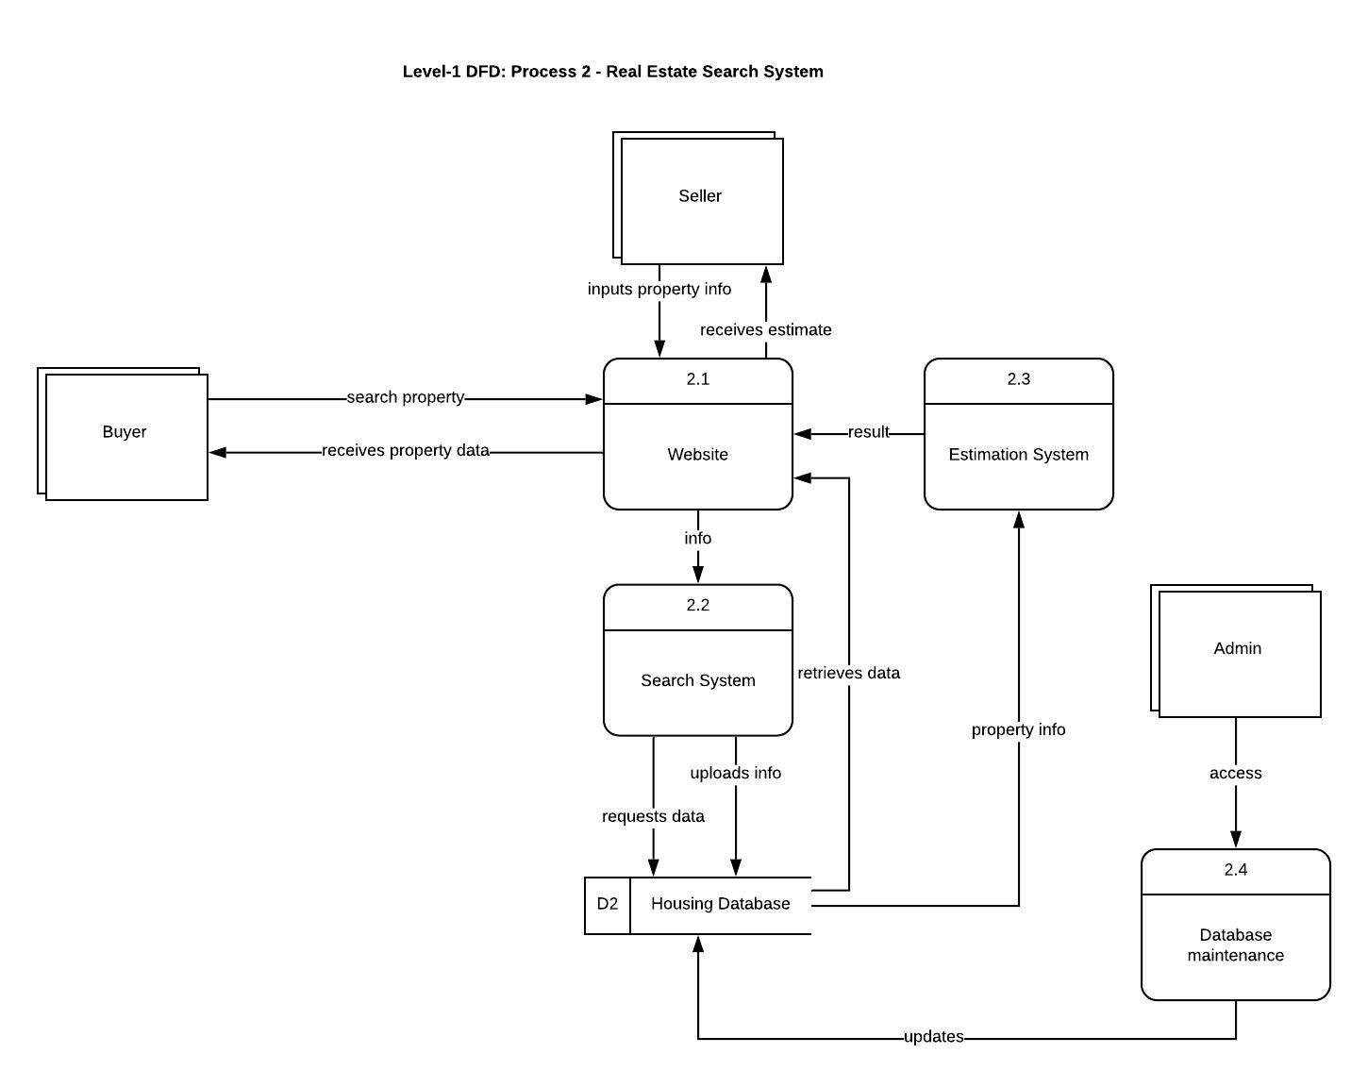

*DFD 3 House Listings:* The system starts with the seller logging into a verified account. Users without an account cannot create any listings, they can only view listings. Once the seller creates a listing, they would then input data into their property listing. It is important to import accurate information because this data will then be sent to administrators to await approval. Any false data will result in the system asking the user to review their listing. Once approved and verified, the listing will then be published on to website, ready to be viewed by buyers. Finally, the data will then be stored into our housing database.

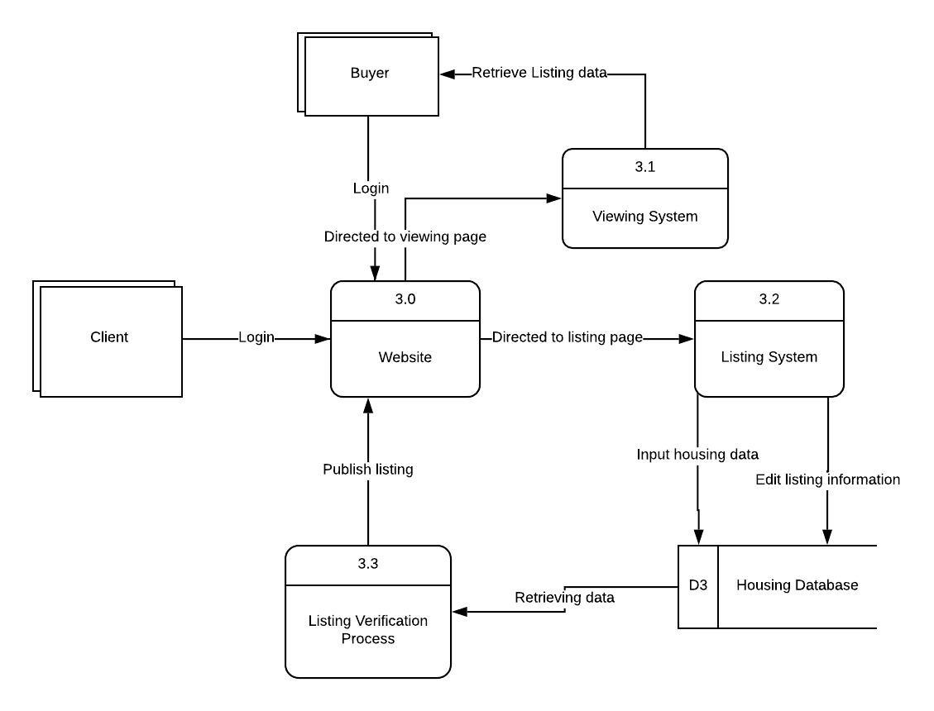

*DFD 4 Renovation Changes:* This process is initiated by the buyer who is accessing the website. It begins with the buyer finding a home they are interested in then choosing the option of renovation changes. After the user has the option to enter with they would like to possibly add an extended room or refurbishments to the home. After they are able to choose which type of either one. Houstimators then looks into the housing database of the homes price per square foot, and calculates the new price based off of that. Houstimators then sends the calculated price to the buyer.

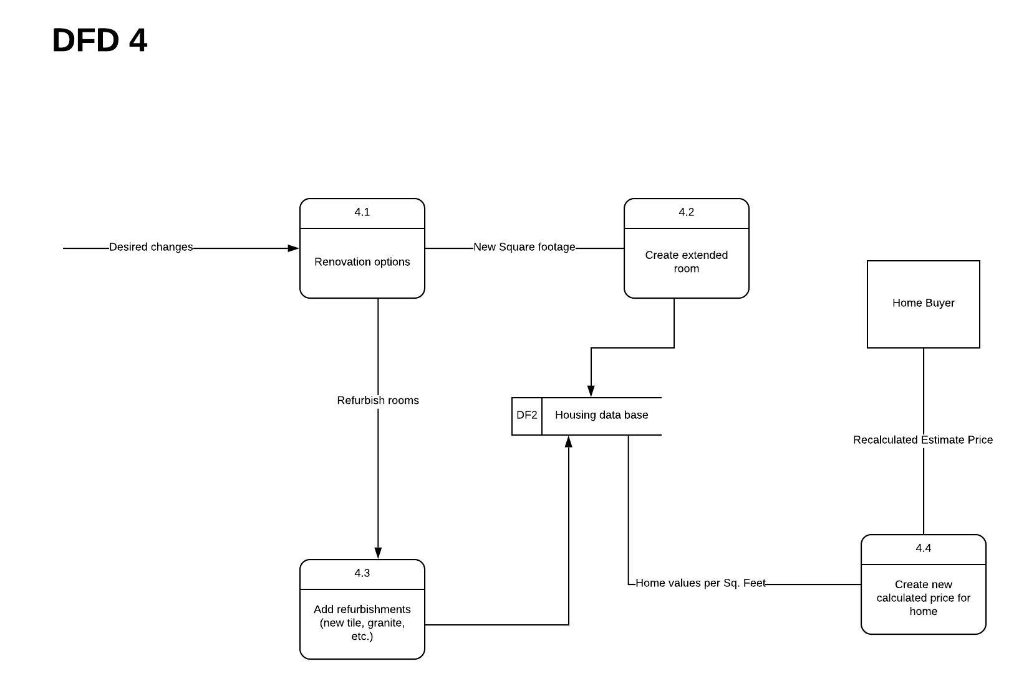

*DFD 5 Chat Server:* This is the level diagram for the customer support chat server that both the buyers and sellers can use to communicate with a system administrative representative for direct, and real-time, assistance. The process begins with the user logging into their profile after directing themselves to the Housetimators website. Once in, the user navigates to the chat support icon to open up the live chat server. This action is automatically sent to the customer service database, which searches for a system administrator that isn’t paired with a user on the server and pairs them up with the user. Once paired, the user and client can communicate and send messages back and forth. Once the user is done, they close the chat server and the database stores a chat log.

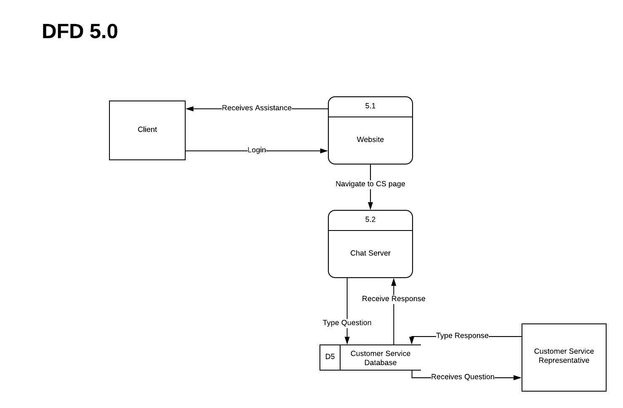

##### *3.1.4 Combined Data Dictionary:*

***DFD Level 1 - Process 1***

Data Flow

* User: User enters log-in information
* Verification: Username and Password is then verified
* Success: Once they have successfully logged in, they can access the site or change their password
* Changing password: User enters new password and then updates it in the database.

Sources/Sinks

* Correct Input: User enter the correct username and password
* Incorrect Input: User does not enter the correct username and password
* Login: User has successfully logged in and can access the site

Sub-Process

* User Log in: User is prompted to enter in information
* User input: User’s input is then cross checked with Customer Database
* Validation: Information matches allowing access to the site
* Change Password: User enters username, when verified allows them to change the password and updates it in the Customer Database.

Data Sets

* Customer Database: Contains user information ( ex. Username and Password)

***DFD Level 1 - Process 2***

Data Flow

* Buyer: inputs property details/information which they are interested in.
* Seller: inputs property details into system.
* Send data: property details are sent and stored in the system to match with potential listings.
* Retrieval: Listings that match the required user information are retrieved and sent back to the user.
* Store data: seller property information is stored in database.
* Interpret data: seller property information goes through estimation system before results are returned.
* Reviewed result: Admin can manage/maintain system in order to prevent any inconsistencies or errors.

Data Sets

* Housing database: contains all property data.

Sources/Sinks

* Buyer: person requesting to view properties that match their criteria.
* Seller: person requesting estimate on the property they have input.
* Admin: administrator who can access the database and makes changes to the system.

Sub-Processes

* Cross-Check Information: compares and retrieves all listing data from the housing database that fits the buyers criteria. In the seller's case, their property is compared to all those similar to it in the same area for accurate estimates.
* Review Individual File: if the information being retrieved does not match the criteria set by the user, an admin will be requested to manually review any inconsistencies.
* Update Housing Database/System: admin will need to manually approve any MLS listing updates to the database and system.

***DFD Level 1 - Process 3***

Data Flow

* Seller : Logs in with a verified account to enable listing feature
* Seller : Inputs accurate property to be verified
* Verification : Admin reviews data and compares it to previous listings to verify
* Data Storing : Data is then stored into our housing database
* Publishing : Listing is published after verification

Sources/Sinks

* Information is correct and verified : Publish listing
* Information is incorrect : User is asked to review listing

Sub-Process

* Housing data is stored in housing database
* Listing edit only by same seller and account

Data Sets

* Housing Database : Data is stored into our housing database

***DFD Level 1 - Process 4***

Data Flow

-Desired Changes: Buyer chooses option for possible renovations.

-New Square Footage: The desired square footage difference is inputted.

-Refurbish Rooms: Desired room refurbishments inputted by buyer.

-Home Values per. Square Foot: The price of homes per square feet is taken from home database and recalculated to desired changes through formula.

-Recalculated Estimate Price: The recalculated price is shown to buyer.

Sub-Processes

-Renovation Options: Different renovation options are shown on screen to buyer who wishes to determine different prices.

-Create Extended Room: If buyer chooses to renovate potential for an extra room, the price is calculated.

-Add Refurbishments (New tile, granite, etc.): If buyer chooses the refurbishment option, this new price is calculated.

-Create New Calculated Price: Uses previous prices for a home’s square footage and uses formula to calculate new one considering renovation changes.

Data Sets

-Housing Database: Stores all listed home prices and previous home listing details.

***DFD Level 1 - Process 5***

Sources/Sinks

* Buyer: User using chat server in regards to buying real estate or other related information.
* Seller: User using chat server in regards to selling real estate or other related information.

Sub-Process

* Post conversation satisfactory feedback questionnaire shown on screen right before exiting the chat server.
* Updates conversation log and feedback to customer service database.

Data Sets

* Customer Service Database: Matches administrator to user on chat server and store conversation related logs.

##### **3.2 Use Cases and Process Models**

**Project Name: Use Case 1 and Process Model**

|  |  |
| --- | --- |
| **Use Case ID:** | Process 1 of level 0 DFD |
| **Use Case Name:** | Login |
| **Use Case Objective:** | Provide users the ability to log in to the server and access the website. |
| **Primary User/Actor:** | Buyer, Seller and Admin. |
| **Trigger:** | Check if the information is in the customer database and if it is there takes them into the site if not asks them to try again. |
| **Use Case Associations:** | Include: Changing Existing Password  Extend: Process 2 -5 of level 0 DFD |
| **Pre-conditions:** | Correct Log-in information |
| **Post conditions:** | User is able to access the site and change password |

*Basic Flow*

|  |  |  |
| --- | --- | --- |
| **Step:** | **User Actions (Inputs)** | **System Response (outputs)** |
| **1** | User logs into website. | System receives request. |
| **2** | User changes their password | System retrieves and sends new information into database. |
| **3** | Validates information | Access website |

*Alternate Flow*

|  |  |  |
| --- | --- | --- |
| **Step:** | **User Actions (Inputs)** | **System Response** |
| **1** | System unable to process request for log-in | System sends error alert. |

**5 Functional Requirements:**

* User ID
* User Username
* User Password
* User Updated Password
* User’s info must be updated to the customer database

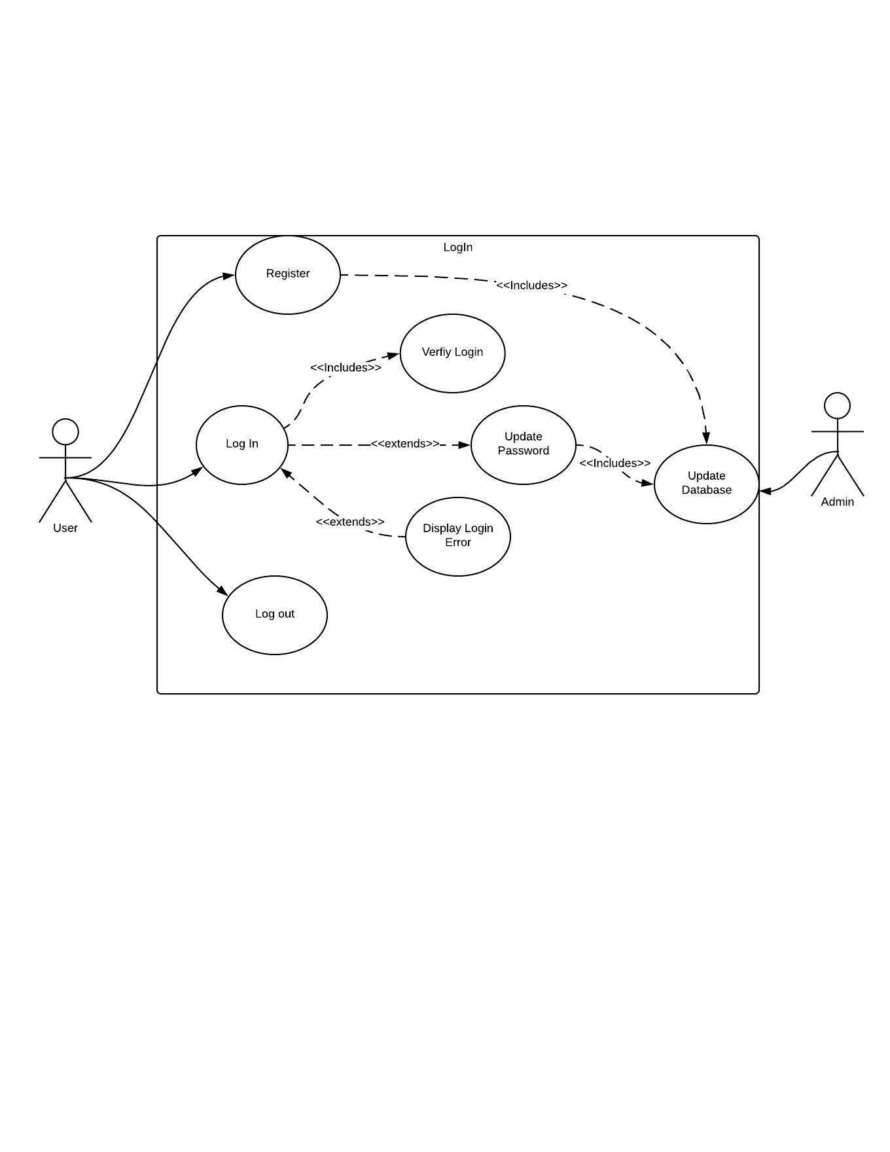

**Project Name: Use Case 2 and Process Model**

|  |  |
| --- | --- |
| **Use Case ID:** | Process 2 of Level 0 DFD |
| **Use Case Name:** | Real Estate Search System |
| **Use Case Objective:** | Provide users with access to real estate listings/information and admin management of database. |
| **Primary User/Actor:** | Buyer, Seller & Admin. |
| **Trigger:** | User searches or inputs property details which is automatically or manually checked by admin. |
| **Use Case Associations:** | Include:  Exclude: |
| **Pre-conditions:** | User Inputs property details. |
| **Post-conditions:** | Requested information received, update database, approval, denial, modifications. |

*Basic Flow*

|  |  |  |
| --- | --- | --- |
| **Step:** | **User Actions (Inputs)** | **System Response (Outputs)** |
| **1** | Buyer enters property details into system. | System sends information to housing database then relays all information back to buyer. |
| **2** | Seller enters their property details into system. | System sends information to a database where it is stored, information is then sent to estimation system and return back to seller. |
| **3** | Admin accesses database for management. | System updates new information after admin manually reviews it. |

*Alternate Flow*

|  |  |  |
| --- | --- | --- |
| **Alt:** | **User Actions (Inputs)** | **System Response (Outputs)** |
| **1** | System is unable to provide seller with property estimate. | System notifies admin of problem. |
| **2** | System is returning incorrect property details to buyer. | System notifies admin.  Admin checks/updates any errors. |

*Use Case Notes*

|  |  |
| --- | --- |
| **Special Requirements:** | Database should only retrieve and release information regarding properties.  Admin must manually approve new properties that aren’t in the existing database.  Company should have a large enough database for information to be continually updated/stored.  Sellers looking for estimates are required to register/login. |
| **Business Rule:** | When sellers are inputting property details for estimate, they must agree for that information to be stored in our system. |

**5 Functional Requirements:**

* Seller must input all required property details in order to receive estimate.
* Buyer must select criteria in order for desired listings to be viewed.
* Database must keep user information confidential.
* Seller property information must be added to the system and stored in database.
* Sellers must have registered account to use estimation system.

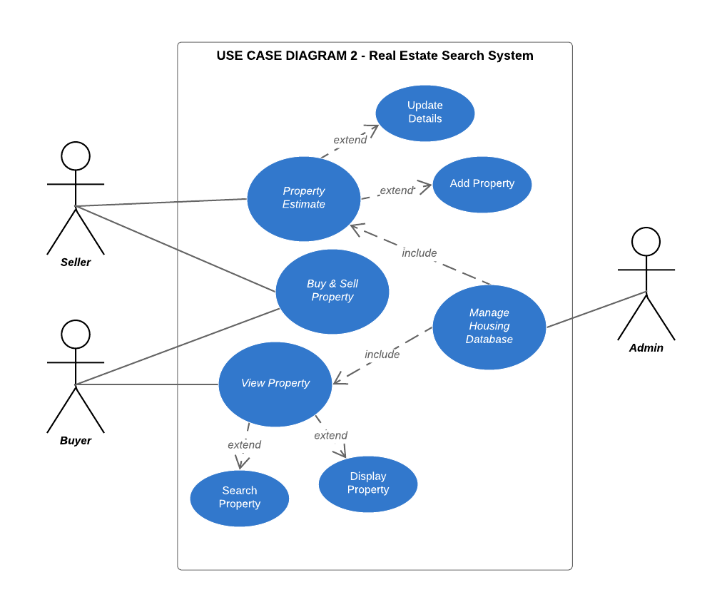

**Project Name: Use Case 3 and Process Model**

|  |  |
| --- | --- |
| **Use Case ID:** | Process 3 of Level - 1 DFD |
| **Use Case Name:** | Listing system |
| **Use Case Objective:** | Manually input housing data on for sale homes to be sent through a verification process to be published on the website. |
| **Primary User/Actor:** | Seller |
| **Trigger:** | Logging into the website and being manually directed to listing system |
| **Use Case Associations:** | Include: Verified login status, Verified account information  Extend: Store housing database, Publish listing on website |
| **Pre-conditions:** | Login and Search System. |
| **Post conditions:** | Publish sellers final listing on to website and store it into the housing database |

*Basic Flow*

|  |  |  |
| --- | --- | --- |
| **Step:** | **User Actions (Inputs)** | **System Response (outputs)** |
| **1** | User enters account credentials | Verifies access if correct, loop log in if incorrect |
| **2** | Direct to listing system | Allows user to manually input housing data information |
| **3** | Input housing data | Information is verified and published |

*Alternate Flow*

|  |  |  |
| --- | --- | --- |
| **Step:** | **User Actions (Inputs)** | **System Response** |
| **1** | Login with incorrect credentials | Denied access to account |
| **2** | Housing data is falsely inputted | Data will be rejected from verification process and not published |

*Use Case Notes*

|  |  |
| --- | --- |
| **Special Requirements:** | Client account information must not be released under any condition.  Housing data must not be released unless authorized. |
| **Business Rule:** | Listings can only be accessed and edited by authorized seller unique account |

**5 Functional Requirements** :

* User must log in with a verified account
* Housing data inputted by user must be completely accurate in order to be verified by admin
* Housing data must only be edited and submitted by the same unique account used to create listing
* Admin must verify the information inputted by user
* There cannot be an already existing listing for a unique home

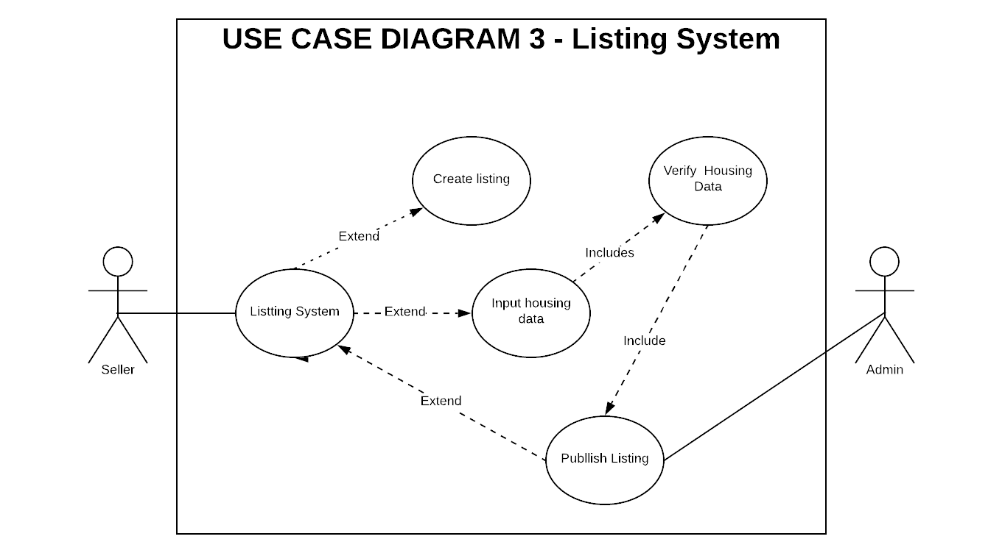

**Project Name: Use Case 4 and Process Model**

|  |  |
| --- | --- |
| **Use Case ID:** | Process 4 of level 0 DFD |
| **Use Case Name:** | Renovation Changes |
| **Use Case Objective:** | Provide users options in renovation changes in homes they are interested (ex; extra room, floor changes etc.) and changes of prices. |
| **Primary User/Actor:** | Buyer and Admin. |
| **Trigger:** | User chooses optional renovation changes. |
| **Use Case Associations:** | Include: Changes in square feet, floor changes and display prices.  Extend: retrieve home price from database and provide new price. |
| **Pre-conditions:** | User inputs desired changes. |
| **Post conditions:** | User receives the difference in prices. |

*Basic Flow*

|  |  |  |
| --- | --- | --- |
| **Step:** | **User Actions (Inputs)** | **System Response (outputs)** |
| **1** | User chooses option to view renovations. | System receives request. |
| **2** | User inputs desired renovation changes. | System retrieves and sends price info from database. |

*Alternate Flow*

|  |  |  |
| --- | --- | --- |
| **Step:** | **User Actions (Inputs)** | **System Response** |
| **1** | System unable to process request for renovation changes. | System sends error alert. |

**5 Functional Requirements:**

* User ID
* Renovation change
* House price
* Estimated recalculated price
* Seller ID

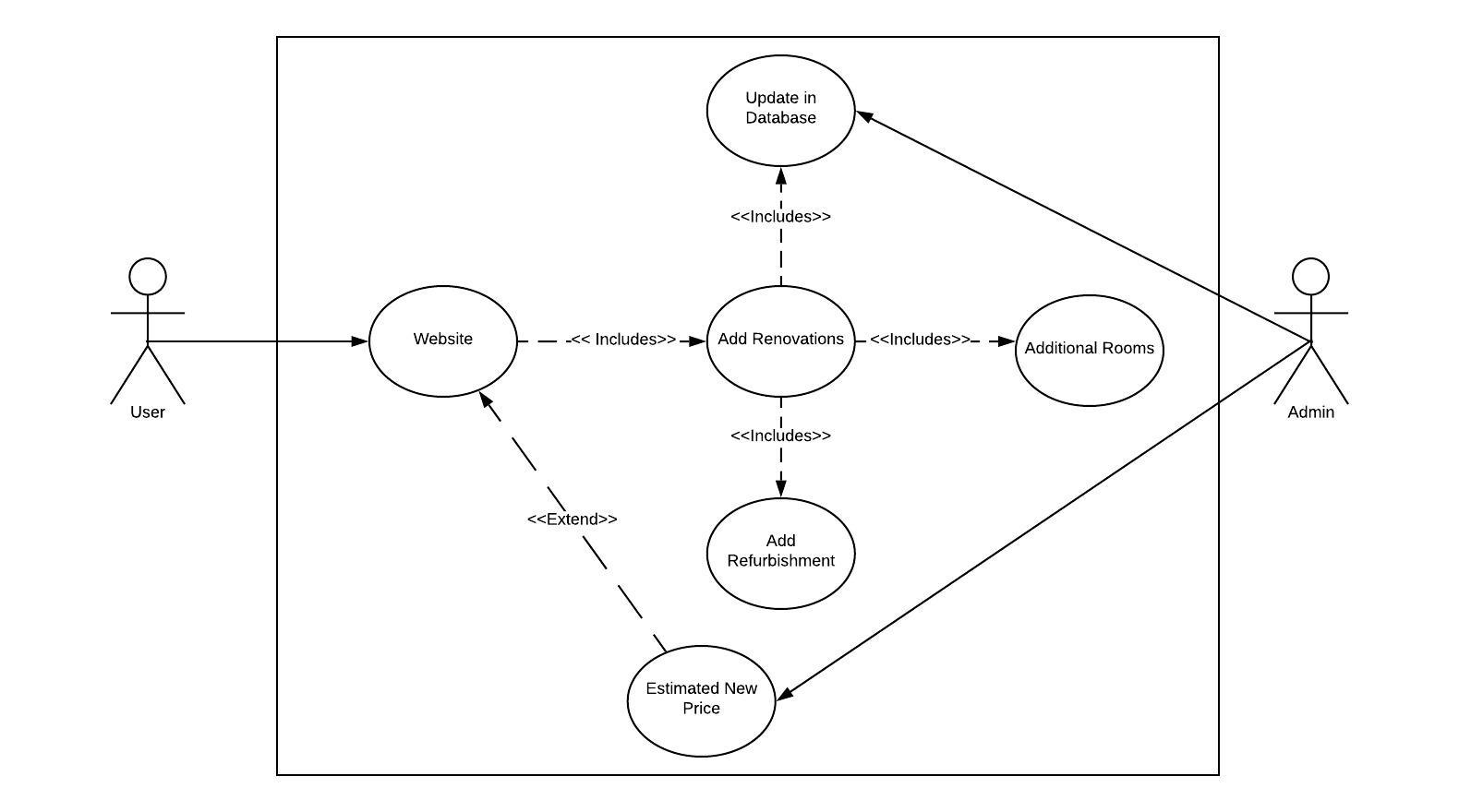

**Project Name: Use Case 5 and Process Model**

|  |  |
| --- | --- |
| **Use Case ID:** | Process 5 of Level 0 DFD |
| **Use Case Name:** | Customer Service Communication |
| **Use Case Objective:** | Communicate with, and assist, users of the website |
| **Primary User/Actor:** | Buyer, Seller & Admin. |
| **Trigger:** | User logs in and navigates to the chat server prompting a message to be typed |
| **Use Case Associations:** | Receive question/messages, send & receive response. |
| **Pre-conditions:** | Message from user needs to be sent. |
| **Post-conditions:** | User receives feedback/response. |

*Basic Flow*

|  |  |  |
| --- | --- | --- |
| **Step:** | **User Actions (Inputs)** | **System Response (Outputs)** |
| **1** | User logs into website. | Loads the user profile. |
| **2** | User navigates to chat server. | New chat window opens up. |
| **3** | User types message. | Database matches available/vacant representative to user server. |
| **4.** | User receives response. | Representative response sent. |
| **5.** | User closes server. | Conversation stored in database. |

*Alternate Flow*

|  |  |  |
| --- | --- | --- |
| **Alt:** | **User Actions (Inputs)** | **System Response (Outputs)** |
| **1** | System connection error. | Notifies user to reload or check connection. |

*Use Case Notes*

|  |  |
| --- | --- |
| **Special Requirements:** | User and representative messages should always remain private unless legal circumstances require review by a member outside those that were in communication in the chat server. |
| **Business Rule:** | After each conversation, conversation history (timestamp) is saved in the user’s profile and in the database. |

**5 Functional Requirements:**

* User must login before accessing chat server so administrator could see background information.
* User must send message in order to receive response..
* Administrators must be able to respond with correct information to ensure client satisfaction.
* Conversations are private, so the database must keep conversation history confidential.
* Chat server requires an internet connection to be operational.

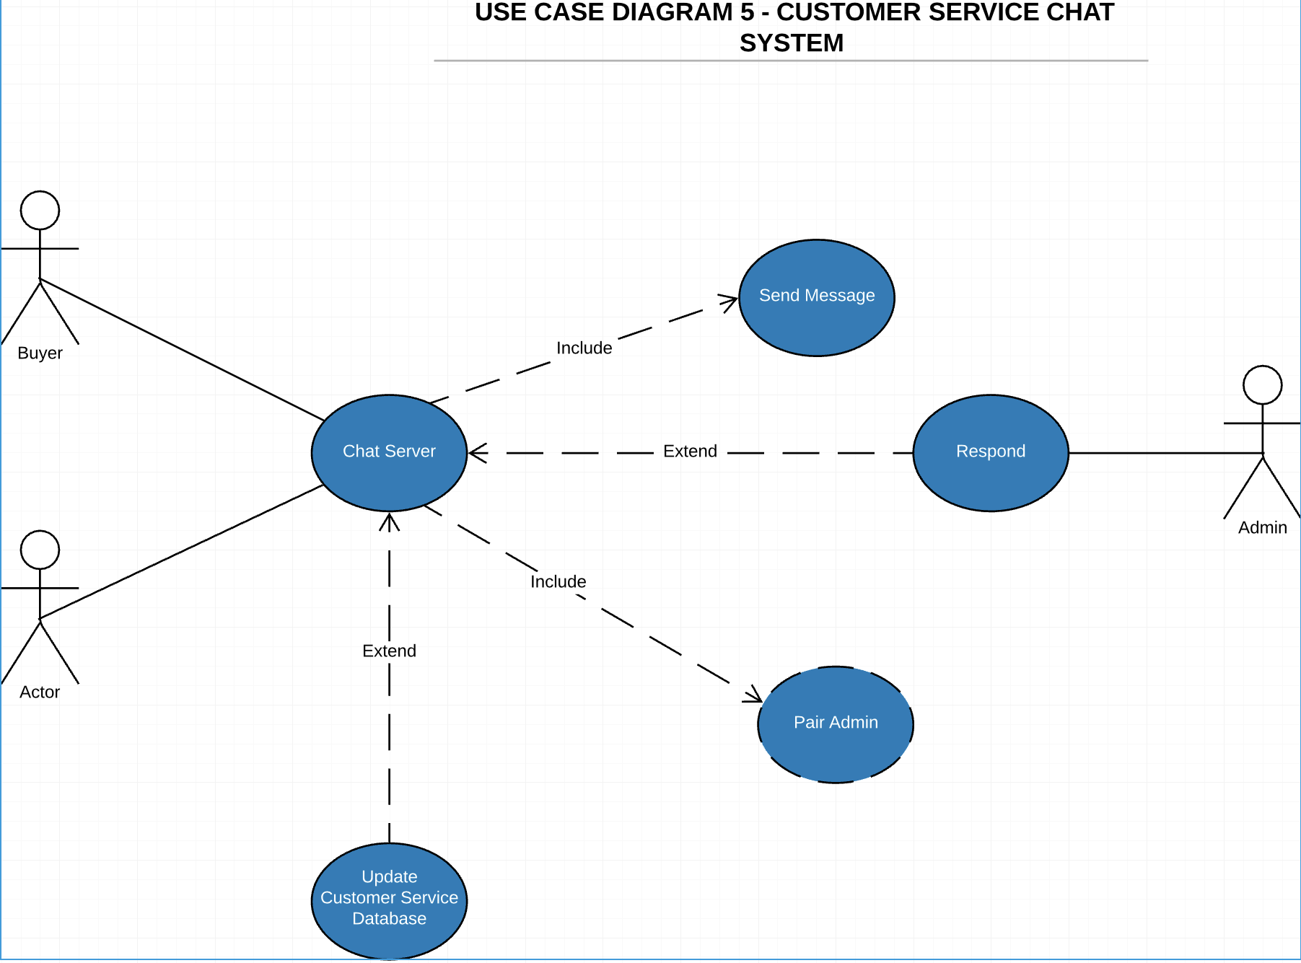**3.3 Data model**

##### *3.3.1 Entity Relation Diagram*

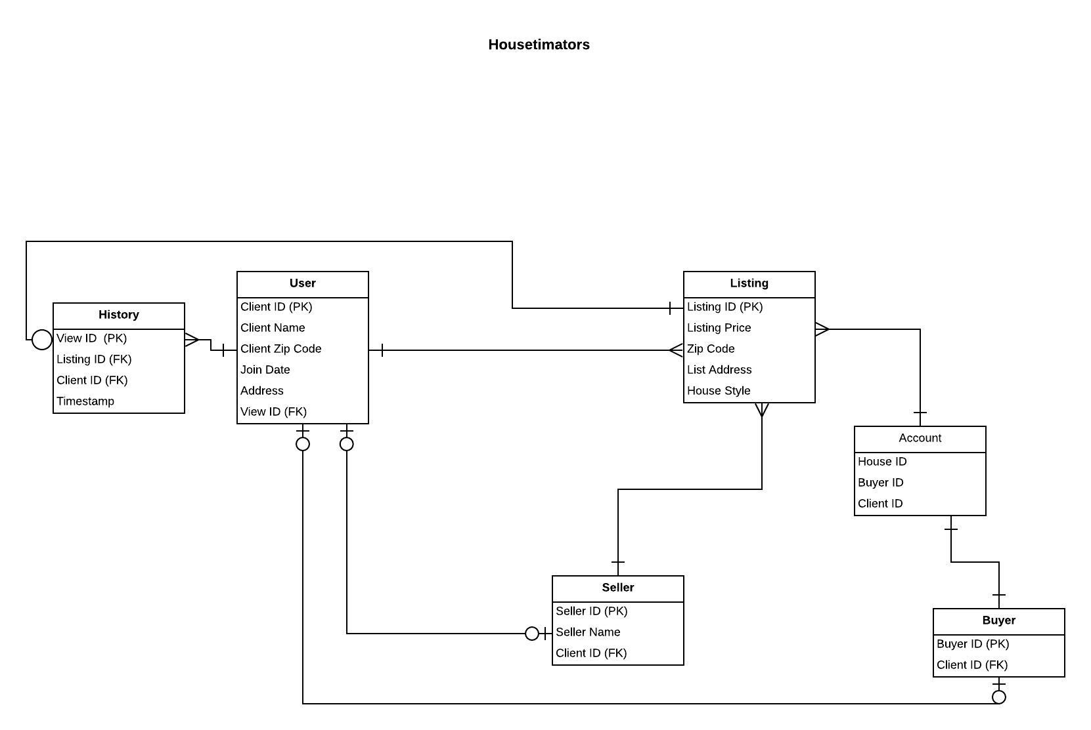

##### *3.3.2 Data Model Specifications:*

Through the inclusion of a number of assigned keys, attributes, entities, and relationships, Housetimators data model satisfies all data requirements. Housetimators principal entities focus is on providing information to users from the data collected. To be more specific, all user entered data is collected and stored to help provide accurate estimates and desired property listings.

### 

### 4.0 System Architecture

##### **4.1 Data Model**

##### *4.1.1 Entity Relationship Diagram (ERD)*

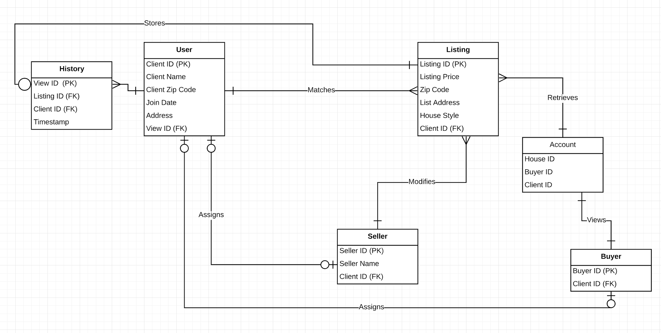

##### 

##### *4.1.2 Data Model Specifications*

Housetimators’s data model satisfactorily meets all of the data needs by using the following- 1. Entities, 2. Defined Relationships (One-Many, Many-Many), 3. Assignment Keys (Primary Key, Foreign Key), and 4. Attributes. The data model represents a network based system in which the clients, buyers and sellers, publish, modify, and view houses on the website. All the data, housing information, clients search and modify on the website is collected and stored to represent client information and to feed the house estimation algorithm. The Housetimators’s data model shows how each entity is related to each other and how they are supposed to interact with each other in a perfect environment. The relationship is established through the respective primary and foreign keys. This data model follows a Platform as a Service (Paas) in relation to Housetimator’s Cloud Architecture.

##### 

##### **4.2. Cloud Architecture**

Architecture

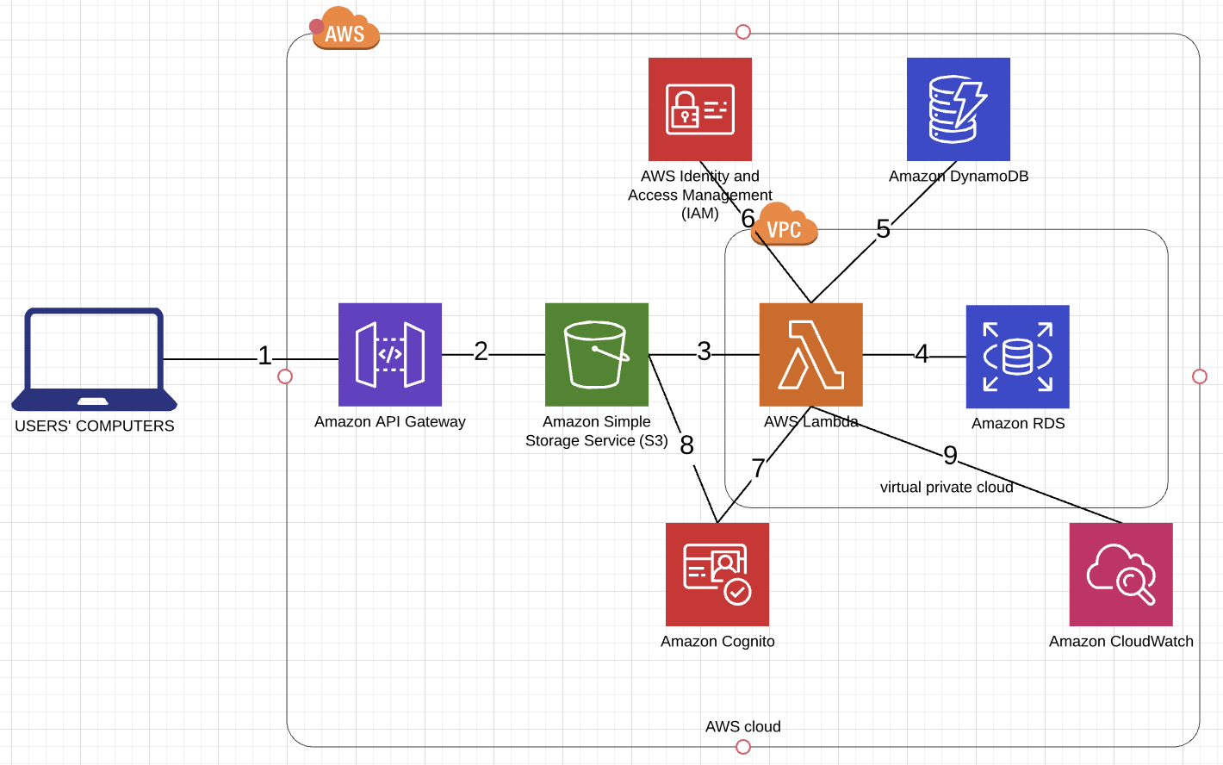

1. The **Amazon Application Program Interface Gateway (API Gateway)** enables users of Housetimators to utilize APIs to input information and to the API Gateway and receive estimates given the inputted data or user information.
2. **Amazon Simple Storage Service (Amazon S3)** is used to store and retrieve the inputted data.
3. **AWS Lambda** is then triggered upon storage of data in S3 and begins to operate in response to the user input.
4. **Amazon Relational Database (Amazon RDS)** will scale the database in the Virtual Private Cloud. Additionally it operates the database throughout various locations.
5. **Amazon DynamoDB** (NoSQL database) stores and retrieves the data after being run by AWS Lambda, regardless of amount. It stores and retrieves information such as housing prices, user account information, and house edits.
6. **AWS Identity and Access Management (IAM)** is used for authentication procedures before the database can be accessed by an administrator. The administrator will be granted access to database containing user information and data.
7. After user information/data is processed by Lambda, **Amazon Cognito** will send verification to the email stored in S3. Admins may be able to track the management of the user access and encryption keys used in authentication process.
8. **Amazon S3** retrieves stored user information to link the verification with and send it back to AWS Lambda.
9. In the end of the architecture, **Amazon CloudWatch** will be monitoring to fix any operational issues and provide insights for the AWS. Administrators can collect operational logs regarding performance monitoring.

##### *4.2.1 Network & Web Tier*

Housetimator’s utilizes the “Network & Web Tier” as a means of dealing with the demands triggered by user’s computers through API Gateway. Application program interface gateway, which is also known as API gateway, plays an intrical part within the cloud architecture as it fills in as a division between the frontend and backend administrations. The utilization of an API Gateway additionally consolidates the backend administrations into a solitary passage point. In order to ensure everything works as it’s supposed to, the “Network & Web Tier” identifies with the “Application Server Tier” so that everything being input/requested by the user goes through the system and relays back the correct information. Each process must go to specific parts of the application server so it can distinguish whether a seller is trying to receive an estimate on their property or if a buyer is searching for available listings.

##### 

##### *4.2.2 Application Server Tier*

In Housetimator’s program, we utilized Lambda in the “Application Server Tier”. Lambda runs the program once the user inserts an input. An example of this would be when the user wants to see what the cost of the house would be if they end up renovating it. Once the program receives this information, it then executes the new price. “Application Serve Tier” also works when the user wants to log in to the system. It takes in their information to verify it in the database. The “Application Server Tier”, works very closely with the “Database Tier”. Our server constantly receives new information, like new houses, verifying a login, and updating user information, that it needs to go through the “Database Tier”, to update and process all the information and store it.

##### *4.2.3 Database Tier*

The “Database Tier” is one that is essential and frequently used through all phases of our application. From beginning to end, the “Database Tier” is used every single time we receive information from the user. All of our data is collected through our application server Lamba. To securely store all users personal information, we will be using Amazon S3 (Amazon Simple Storage Service). We will also be using Amazon RDS alongside Lamba to scale all of our data that we receive from users. S3 and RDS will allow us to easily set up our database, and organize it as well. We will be using Amazon DynamoDB as our key-value database. DynamoDB will be where all the processed housing prices, user account information, house edits, etc will eventually be stored.

##### *4.2.4 Authentication Tier and Security Configurations*

The AWS services that Housetimators uses in their program is the AWS Identity and Access Management, Amazon Cognito, and Amazon Cloudwatch. IAM is mainly used for administrative purposes, as it helps it requires authentication for access to our databases. Databases can be accessed by any employee with authentication credentials. Amazon Cognito is configured by Housetimators, to send verification code to the email of potential l buyers or sellers signing up for a Housetimators account. After which the buyer or seller would be able to log in with a username and password and be able to list homes or schedule tours. The Amazon Cloudwatch is essentially used to fix any internal issues with Housetimators website as it gives insights on any data, metrics on performance and operational issues.

### 

### 5.0 User Interface and User Experience

##### **5.1 User Interface**

The primary users for our online UI are all those who are interested in buying or selling property. The whole design process of the UI was specifically based on providing users with a new and improved way to shop around for properties in addition to finding out reasonable and accurate valuations for their properties. By catering to buyers and sellers, we could help conduct multiple business transactions in one place. It was also extremely important to make sure the UI was as user friendly as possible, so that user would be able to navigate through the various parts of the website with ease. Since user experience is everything and it’s important to draw users in and keep them coming back. Therefore, we opted for a very simplistic layout and design. We kept the bare essentials in the various interfaces and stuck to a minimalistic color scheme to keep the focus on the properties.

One of the key features of our website is the property estimator. Not many real estate websites have this aspect implemented. The structure of our estimator was planned to get straight to the point. Find out the basic information such as address in order to gage a price estimate before the additional information that will be entered such as the amount of rooms, square footage, etc. After everything is run through our system and filtered, will be able to provide the user with an estimate. The whole process is quite swift and effortless.

##### *5.1.1 Dialogue Diagram*

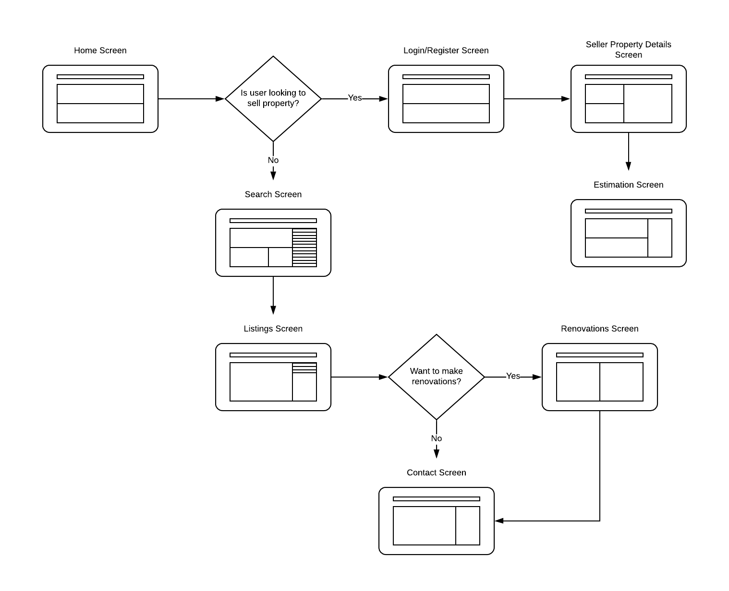

##### **5.2 User Experience (UI Prototypes)**

***User Interface:***

**Home screen:** User has the ability to click whether they want to buy or sell property.



**Search screen:** User is able to filter what they want to search.

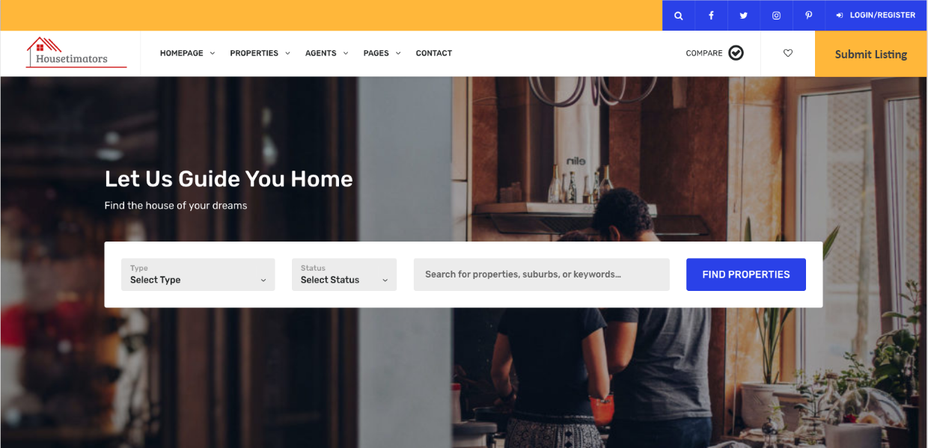

**Listings screen:** User is able to look through all the listings and view more information about it.

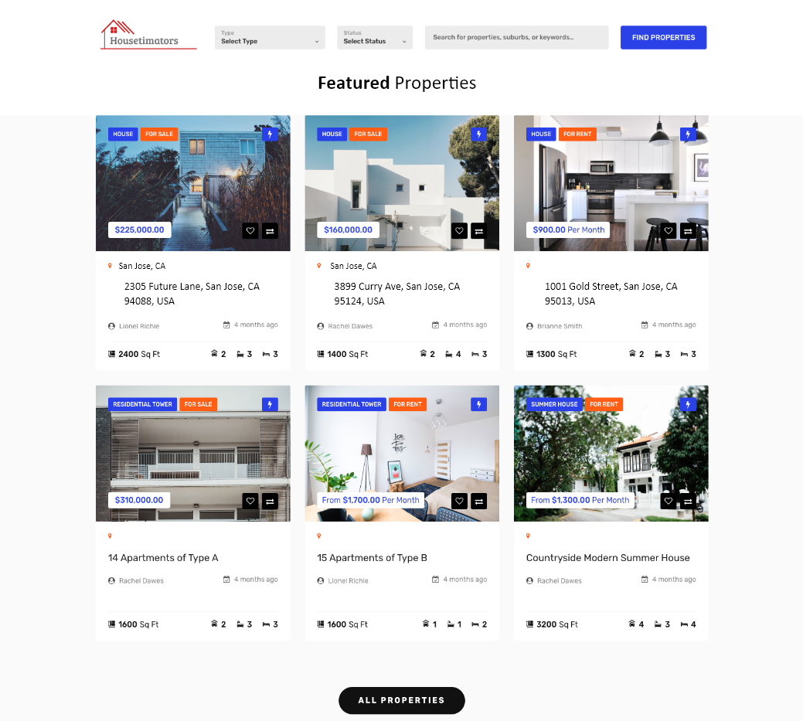

**Login/Register screen:** User can either log in or register to be able to access more exclusive features on the website.

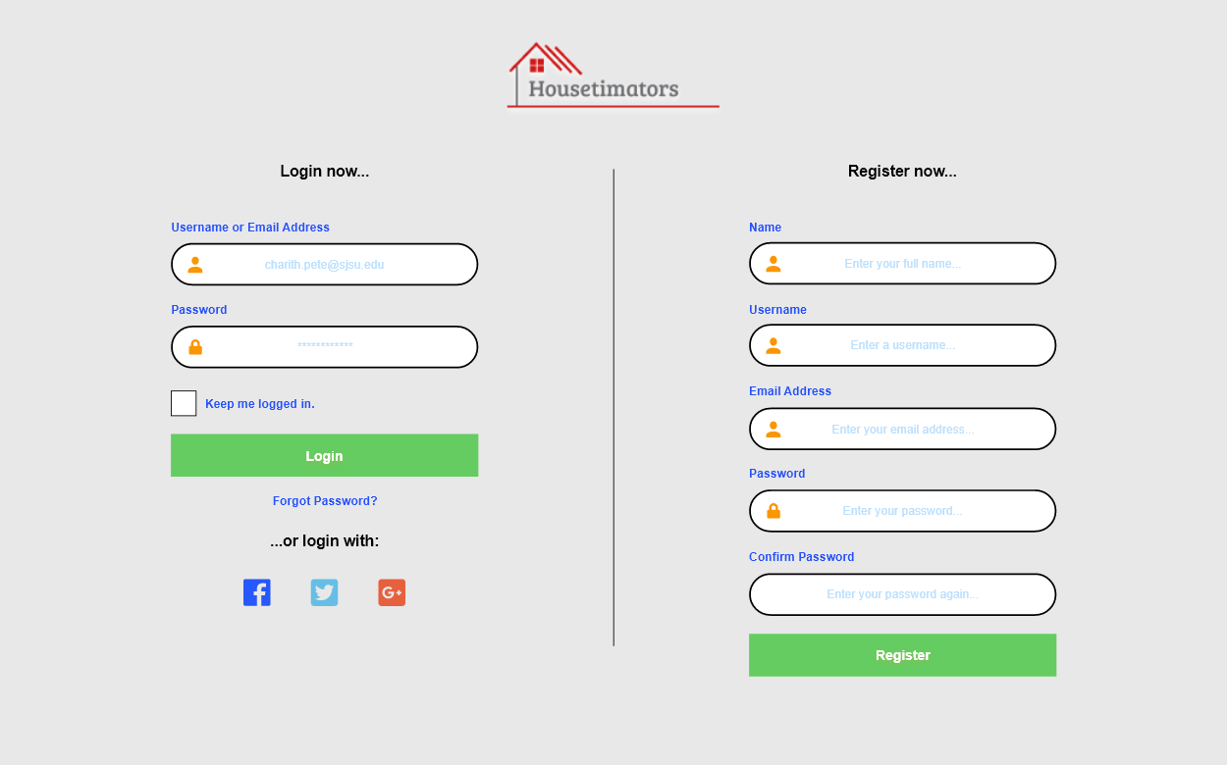

**Contact screen:** If a user is interested in a listing, Housetimators provides various real estate agents that they can get in touch with.



**Seller Property Details screen:** Users interested in receiving en estimate on their property will need to fill out the details below.

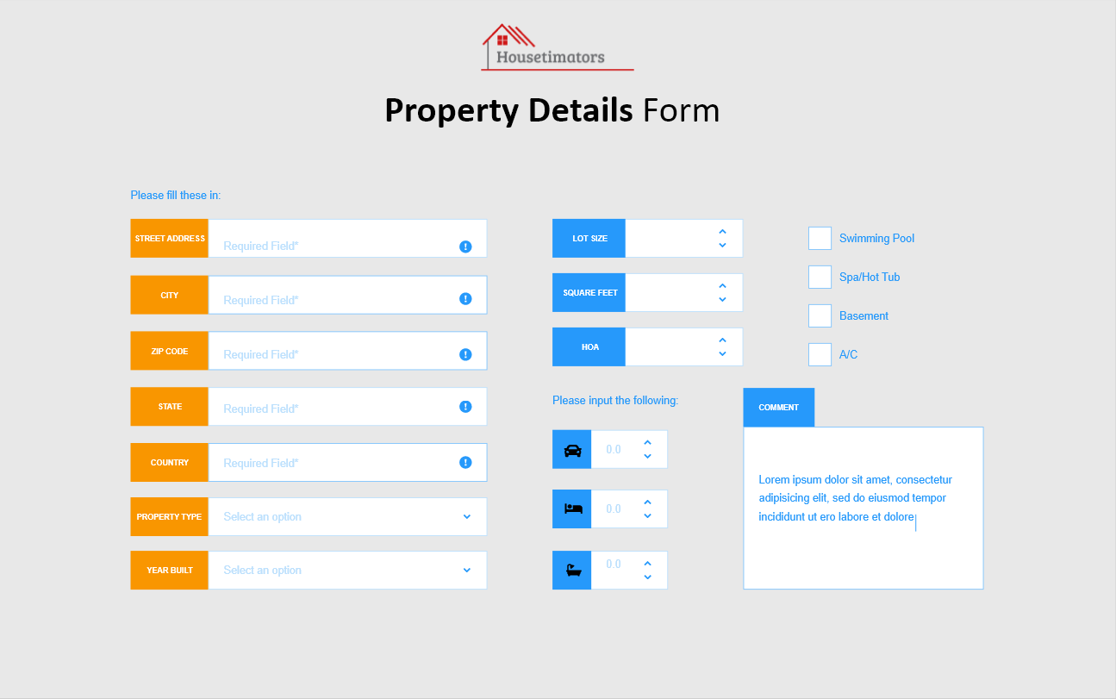

### 6.0 Implementation and Budget

##### **6.1 Development and Test Plan**

Approximate Start Date: June 2020

Approximate End Date: January 2021

**Milestones**

Month 1-4: **Development and coding**

The programmers and other specialists, like software specialist, will sit together and start planning out everything. This includes the code, security, cloud, database, interface and analytics. Software specialists are also responsible for documenting everything from the process to the progress of the code. The managers are checking up on the progress and based on where they are, adjusts the time line or make changes to become more efficient on time. The software engineers work alongside the data analysts. They both are checking and testing the software on its functionality, usability and performance.

Month 5: **Beta testing, release candidates and refinements**

Software specialists are making the refinements. Quality assurance is doing the fit-and-finish testing. The users can test the system through the beta.

Month 6: **Deployment, maintenance and support**

The software is now officially published. Real Estate agents page is now active, the chat support is up and running 24/7. Database is being constantly monitored and updated.

1. Introduction
   1. Objective of the test plan
      1. The objective of this test plan is to make sure that Housimator’s service can be launched successfully with limited malfunctions. It will have preventive and perfective controls. The testing is done by multiple people including programmers, managers, clients and more.
   2. Method of testing
      1. Test will be done weekly to make certain that the security and functionality are working smoothly
      2. Code
         1. Integration Testing: putting all the code together to build the program
         2. Acceptance Testing: users will test the information system. The end result is the user being able to work through it and accepting it
         3. Beta Testing: users can now test the completed system using actual data in the user environment
         4. Regression Testing: testing the existing applications to ensure that when a change is made, the system won’t end up shutting down
2. Test material
   1. Test plans
      1. User acceptance test
      2. Pilot test
   2. Test case
      1. Stress test
   3. Test scenarios
      1. Security test
   4. Test log
      1. Log is created to keep track of the performances based on the test
3. Testing requirements
   1. Hardware
      1. Test the hardware by seeing if it supports the software and if it will run it well
   2. Software
      1. Testing code
      2. User acceptance
      3. Inspections
   3. Personnel
      1. Managers
      2. Clients
      3. Programmers
      4. Quality Assurance
4. Procedure control
   1. Test initiation
      1. Test are being done weekly
         1. Clients and Quality Assurance
   2. Test execution
      1. After the test are done and noted, then the data is analyzed
         1. Quality Assurance
   3. Test failure
      1. Errors are caught and will work with software specialists to resolve them
         1. Quality Assurance
   4. Document control
      1. Documents the test and evaluates them
         1. Quality assurance
5. Test specific plans
   1. Criteria for passing test
      1. Runs smoothly
      2. Functionality, usability and performance all pass the test
      3. Users are satisfied

##### **6.2 Public Launch, Installation or Deployment Plan**

Since our website is focusing on the San Jose region and has various features, the phased installation plan would be quite feasible as we could install each part of our system over time. This would ensure that every part of our website/system is running to the exact way it was designed. It’s crucial that our databases contains not only the necessary property information, but also things such as videos, photos and user information. With this in mind we would need to go through all the features on each page and make sure nothing is out of place or order. Essentially, this would be considered as the alpha testing part as we are making sure everything is compatible and identifying any bugs or issues. Once we are done with this step, we would move onto beta testing where we would allow the website to be tested by a limited number of people who are interested in this particular product. This would allow us to get feedback on our website and make any updates or changes before officially launching. After all the necessary testing is completed, we will have a support system as well as analytics that will track and measure user interests to help with future improvements.

1. Support
   1. We will have a chat support system where users will be able to talk to a system administrative representative for direct and real-time assistance. If no representative is available, users will be able to raise their issues in the chat support system and a representative will get back to them as soon as possible.

##### **6.3 Maintenance Plan**

I. Maintenance/Improvement Plan

1. Maintenance on system will be ran by hired IT Specialists, developers will help in maintaining as well as improve the functionality of the system.
2. We will be implementing corrective maintenance and perfective maintenance. The system will be updated every few weeks to help improve the system’s functionality.

##### **6.4 Budget and Budget Narrative**

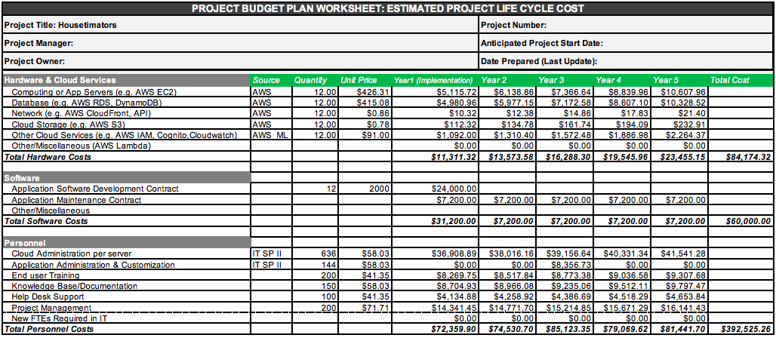

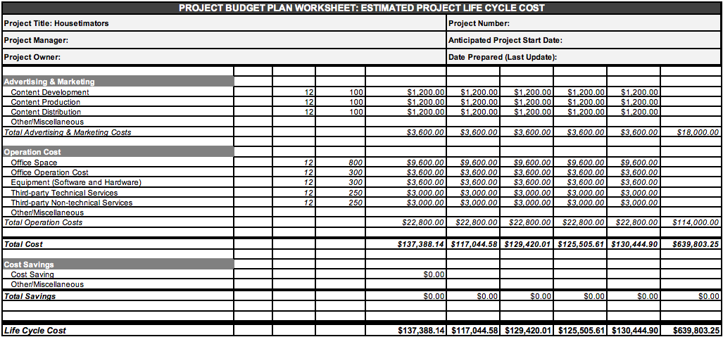

Project Personnel

* IT/MIS/CS: Specialists helping with the implementation and maintenance of the IT system in Housetimators.
* Cloud Admin: Help in managing the cloud services and servers for the system.
* App Admin: Installing and updating internal and external applications for the system.
* End-User Training: Provides help to users on the Housetimators who encounter issues or defects on our websites.
* Documentation: Document coding, system procedures, testing and maintenance support.
* Knowledge Base/Help Desk: Provides technical assistance in software, hardware and other computer programs.
* Project Management: Organizes projects, distributes project responsibilities and makes sure projects are completed within budget.

|  |  |  |  |  |  |
| --- | --- | --- | --- | --- | --- |
|  | Average Salary | Fringe Benefits Multiplier (52.2%) | Total Annual Cost | Hourly Rate | FTE% |
| IT/MIS/CS Specialist I | **$**56,397.00 | 1.525 | $86,005.43 | $41.35 | 100% |
| IT/MIS/CS Specialist II | $79,153.00 | 1.525 | $120,708.33 | $58.03 | 100% |
| IT/MIS/CS Specialist III | $97,804.00 | 1.525 | $149,151.10 | $71.71 | 100% |
| Cloud Admin | $78,654.00 | 1.525 | $119,947.35 | $29.83 | 41% |
| App Admin | $56,987.00 | 1.525 | $86,905.18 | $41.86 | 10% |
| End User Training | $57,134.00 | 1.525 | $87,129.35 | $51.72 | 11% |
| Documentation | $55,477.00 | 1.525 | $84,602.43 | $41.60 | 27% |
| Help Desk Support | $49,660.00 | 1.525 | $75,731.50 | $30.14 | 21% |
| Project Management | $75,992.00 | 1.525 | $115,887.80 | $30.22 | 90% |

**Software Contracts**

Application Software Development Contract (12 months*$2000)= $24,000

Develops and creates the software

Application Maintenance Contract ($24,000*60%)=$14,400

Regular fixes and maintenance on software

**Hardware and Cloud Services**

App Servers (12 months*$426.31/unit)= $5,115.72

AWS EC2, creates optimal computing in the cloud

Database $415.08/month

AWS DynamoDB (12 months*$91.49/unit)=$1,097.88

Stores and retrieves all amounts of data

AWS RDS (12 months * $26.96/unit) = 323.59

Network

AWS API Gateway (12 months*$0.86/unit)= $10.32

Monitors and develops API being utilized

Cloud Storage (12 months* $0.78/unit)= $112.32

AWS S3 stores and retrieves data from the user

Other Cloud Services= $91.00/month

AWS Lambda (12 months * $0.60/unit)= $7.20

Runs code, operates from user input

AWS IAM (12 months * $.70/unit)= $8.40

Authentication to access database

AWS Cloudwatch (12 months * $2.10/unit)= $25.02

Provides insights and fixing operational issues in system

AWS Cognito (12 months *$4.19/unit)= $50.28

Allows and sends verification of user to admin

**Operation Costs**

Office Space (12 months * $800 rent)= $9,600

Renting office space

Office Operation Cost (12 months * $300) = $3,600

Costs for utility, internet, phone, cleaning, and cameras

Software and Hardware (12 months * $300) =$3,600

Functional Software and Hardware for employees

### **Appendix A**

Project Management Documentation:

Team Members:

* Neda Amin
* Ricky Bhatia
* Leila Nakasone
* Charith Pete
* Ryan Tran

Project Team Agreement:

1. Real Estate
2. Ricky Bhatia, Back-end Lead

Leila Nakasone, Implementation Lead

Charith Pete Front-end Lead

Ryan Tran, Business Lead

Neda Amin, Project Lead

1. Wednesdays, 12 pm - 1 pm. If not all team members are able to meet on this day/time, we will arrange a Zoom meeting at a mutually convenient time, or Monday’s at 12-1 pm
2. Yes, we opened a workspace at Asana with all group members joining. We also named our group according to your guidelines and invited you.